(Sprint 1 Plan) Island Reservation

Version 2 4/19/2022

**Goal**: The goals of this sprint are to set up the project by creating a git repository and setting up a database. We would also like to create the gallery page, login page, and welcoming page.

**Task listings:**

**User Story 1: As a customer of a booking service, I would like to create an account so that I may save all of my booking information and personal details. (21 story points)**

Task 1: Design a sign up page. (4)

Task 3: Design a login page. (4)

Task 5: Create a collection in the database to hold user information. (0.5)

Task 6: Create a sign up endpoint that can send new user information to the database and a sign up schema. (4)

Task 7: Sign up new users using the sign up endpoint. (3)

Task 8: Create a login endpoint that checks if the user’s information matches the information in the database and a login schema. (4)

Task 9: Log a person into their account using the login endpoint. (3)

**User Story 2: As a person who wants to reserve an island, I want a way to be able to see a list of available islands so I can reserve them. (8 story points)**

Task 1: Design a template page where all of the islands will be displayed. (5)

Task 2: Add hard-coded island information to the page. (1)

Task 3: Create a collection in the database to hold all of the island information. (0.5)

Task 4: Create a get endpoint that can fetch all of the island information in the database and connect it to the frontend. (5)

Task 5: Display the information from the database on the website. (1)

**Team roles:**

Abdel Rahman Alnajjar : Frontend Developer

Suneet Bhandari : Frontend Developer

Minghui Wen : Frontend Developer

Maiah Pardo: Frontend Developer

Jonathan Ly : Backend Developer

Wilson Chen : Backend Developer

Jose Jimenez : Backend Developer

**Initial Task Assignment:**

Minghui Wen: User Story 2, Task 1 create a gallery page that displays information about islands.

Abdel Rahman alnajjar: User Story 1, Task 1 create login page that takes user information.

Wilson Chen: User Story 1, Task 3 connect Login page to backend database.

Sunnet Bhandari: User Story 2, Task 3 Create a Front page for the website.

Jonathan Ly: User Story 1, Task 2 Set up a remote database for the website.

Jose Jimenez: User Story 1 task 2, Set up collections in the database for island information.

**Burnup Chart:**

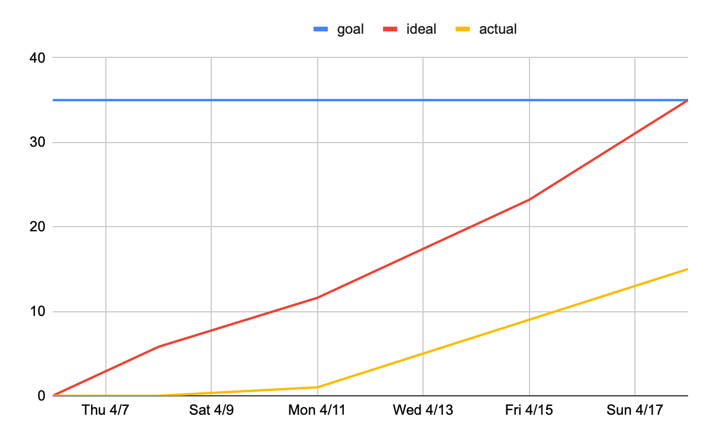

**Scrum Board:**

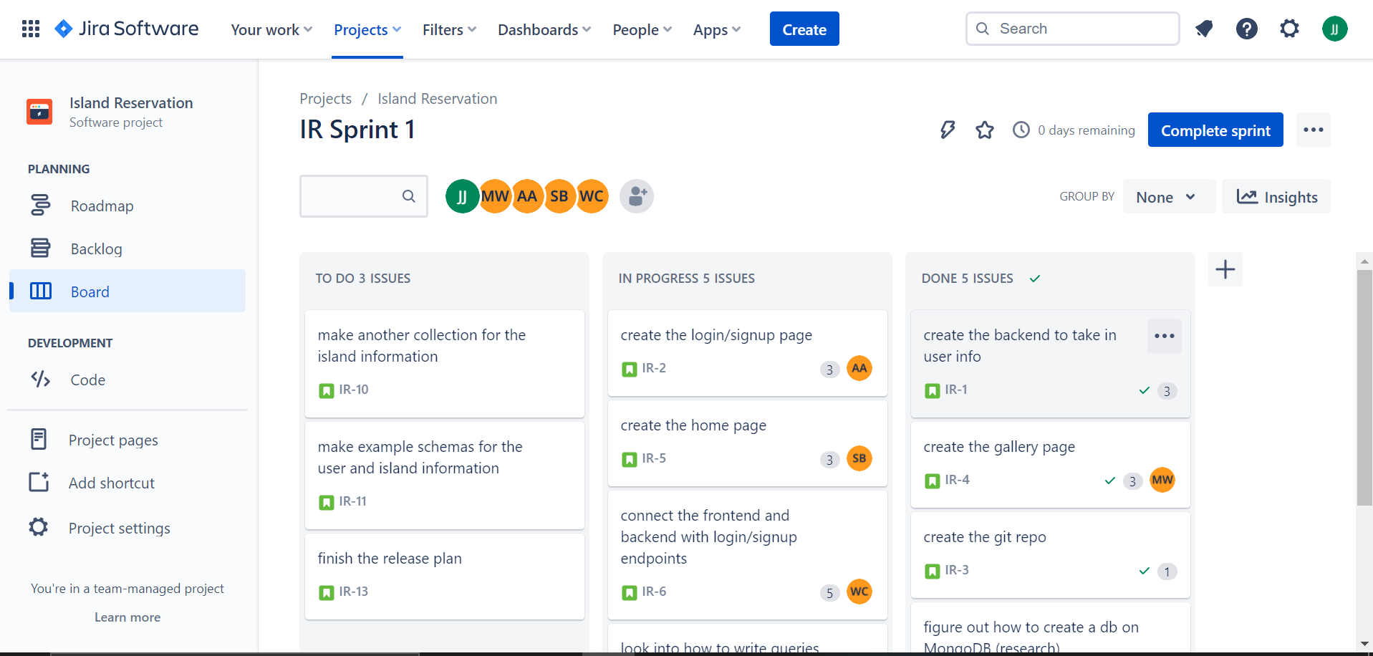

<https://islandreservation.atlassian.net/jira/software/projects/IR/boards/1>

**Scrum Times:**

Mon/Wed/Fri : 9:05am - 9:30am

TA meeting: Monday Trevor 1:30pm - 2:15pm